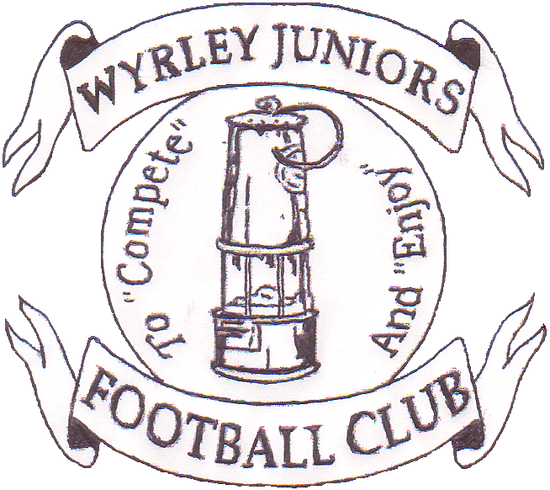

2015
At
Wyrley Juniors FC
Long Lane, Essington. WS6 6AT
Staffordshire Community club of the year
2004, 2006, 2009, 2011 & 2013.
West Midlands Region Community Club of the year 2006 & 2011
National Community Club of the year 2011
The Queens Award for Voluntary Service 2013
You are invited to apply for entry into the 18th Wyrley Sevens.

Age Groups:
Saturday 13th June – Boys 7s & 9s
Sunday 14th June – Boys 8s & 10s
Entry Fee:
£30 per team, payable upon application.
Teams will be accepted into the tournament in the order application forms are received, although the organising committee reserve the right to refuse entry. Confirmation of acceptance to the tournament will be forwarded within 14 days of the tournament.
Tournament places are limited due to new venue, apply early to avoid disappointment.
Teams & Squad size:
7s & 8s – 5 a side, max squad 10
9s & 10s – 7 a side, max squad 12
Facilities:
Qualified First Aiders, Wyrley Juniors Club House with licensed bar. Hot and Cold drinks and food available. Football clothing Stall, Photographer, ice cream man.
Entry to site: £2 per Adult.
A strict one way system will be adopted, a drop off area will be provided on site, When leaving a left hand turn only will be available, Marshalls will be directing traffic.
Parking is limited so car sharing where at all possible would be much appreciated.
No parking will be allowed in Long Lane due to this being a residential area.
To: Kate Foreman, 6, Shanklin Close, Walsall. WS6 6LZ
Telephone; 07715282559
Name:........................................................ Email .........................................................................
Address....................................................................................................................................................................................................................................................................................................
Telephone.........................................................................................................................................
Club Name................................................................. FA Affiliation no.............................................
Please find enclosed a cheque for £...............payable to Wyrley Juniors FC to cover entry into the following age groups
Saturday 13th June: Under 7s ......................... Under 9s..............................
Sunday 14th June: Under 8s.......................... Under 10s............................
Team Colours.............................................. Affiliated League.........................................................

