Wyrley 7s

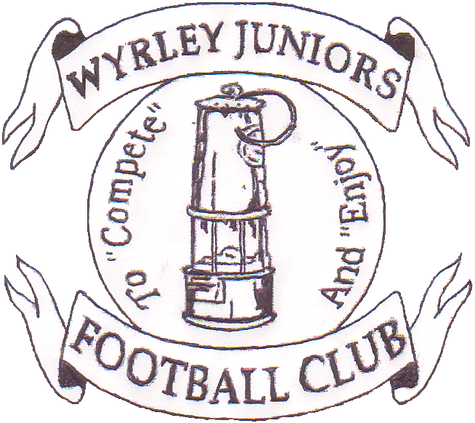

2017
At Wyrley Juniors FC
Long Lane, Essington. WS6 6AT
Staffordshire Community club of the year
2004, 2006, 2009, 2011,2013 & 2015
West Midlands Region Community Club of the year 2006 & 2011
National Community Club of the year 2011
The Queens Award for Voluntary Service 2013
Sport across Staffordshire & Stoke Community Club of the year 2015
You are invited to apply for entry into the 21st Wyrley Sevens.

Age Groups: As season 2016/17.
Saturday 8th July
MORNING TOURNAMENT ONLY
GIRLS Under 8s - 7v7, GIRLS Under 10s - 7v7, GIRLS Under 11s - 9v9
and GIRLS Under 12s - 11v11
AFTERNOON TOURNAMENT ONLY
GIRLS Under 13 - 11v11, GIRLS Under 14 - 11v11 and GIRLS Under 16 - 9v9
All leagues will have 4 league games and Final,
Entry Fee:£30 per team, payable upon application.
Teams will be accepted into the tournament in the order application forms are received, although the organising committee reserve the right to refuse entry.
Tournament places are limited so please apply early to avoid disappointment. Places are not confirmed until payment and application form has been received.
Facilities:
Qualified First Aiders, Wyrley Juniors Club House with licensed bar. Hot and Cold drinks and food available. Football clothing Stall, Photographer, ice cream man.
Entry to site: £2 per Adult.
A strict one way system will be adopted, a drop off area will be provided onsite, Marshalls will be directing traffic.
Car Parking is limited so car sharing where at all possible would be much appreciated.
No parking will be allowed in Long Lane due to this being a residential area.

(PLEASE NOTE: ANY QUERIES AFTER 1ST JULY 2017 CONTACT
SARE MICHAEL: 07505074434)

To: Kate Foreman, 6 Shanklin Close, Walsall WS6 6LZ
contact 07715282559 or email: kateforeman@sky.com
Name:........................................................ Email ....................................................
Address…………………………………………………………………………………………………………………………………………..
Telephone...................................
Club Name.................................................................
FA Affiliation no.............................................
Please find enclosed a cheque for £...............payable to Wyrley Juniors FC to cover entry into the following age groups
Saturday 8th July:
MORNING Under 8………………….. U10………………………, U11………………………
Under 12……………………..
AFTERNOON Under 13…………………… Under 14………………………. Under 16………………………..
Team Colours..............................................
Affiliated League……………………………………………….

PLEASE NOTE; ANY QUERIES AFTER 1ST JULY 2017 CONTACT
SARE MICHAEL:07505074434

