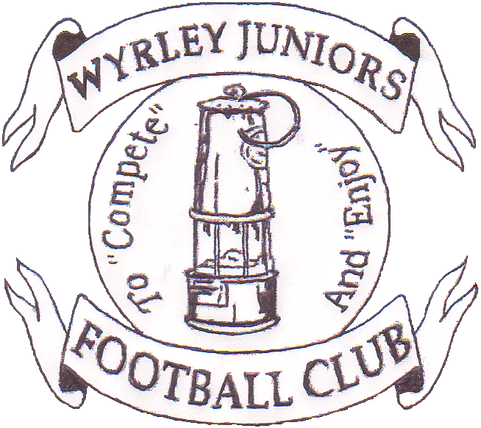

WYRLEY 7s

2016
At
Wyrley Juniors FC
Long Lane, Essington. WS6 6AT
Staffordshire Community club of the year
2004, 2006, 2009, 2011,2013 & 2015
West Midlands Region Community Club of the year 2006 & 2011
National Community Club of the year 2011
The Queens Award for Voluntary Service 2013
Sport across Staffordshire and Stoke Community Club of the Year 2015
You are invited to apply for entry into the 19th Wyrley Sevens.

Age Groups: AS AT SEASON 2015/2016
Saturday 9TH JULY
MORNING -Boys U12 11v11 AND U14 11v11
AFTERNOON - Boys U11 9V9 AND U13 11V11
All age groups will be 1 league of 6 teams
Entry Fee:
£30 per team, payable upon application.
Teams will be accepted into the tournament in the order application forms are received, although the organising committee reserve the right to refuse entry.
Tournament places are limited due to new venue, apply early to avoid disappointment. Places are not confirmed until payment has been received.
Facilities:
Qualified First Aiders, Wyrley Juniors Club House with licensed bar. Hot and Cold drinks and food available. Football clothing Stall, Photographer, ice cream man.
Entry to site: £2 per Adult.
A strict one way system will be adopted, a drop off area will be provided on site, Marshalls will be directing traffic.
Car Parking is limited so car sharing where at all possible would be much appreciated. No parking will be allowed in Long Lane due to this being a residential area.

To: Kate Foreman, 6 Shanklin Close, Walsall, WS6 6LZ
email:kateforeman@sky.com Telephone:07715282559
Name:........................................................ Email .........................................................................
Address....................................................................................................................................................................................................................................................................................................
Telephone.........................................................................................................................................
Club Name.................................................................
FA Affiliation no.............................................
Please find enclosed a cheque for £...............payable to Wyrley Juniors FC to cover entry into the following age groups
Saturday 9th July Morning Under 12 …………………………, Under 14……………………….
Afternoon U11…………………………, Under 13……………………………….

Team Colours..............................................
Affiliated League……………………………………………….

