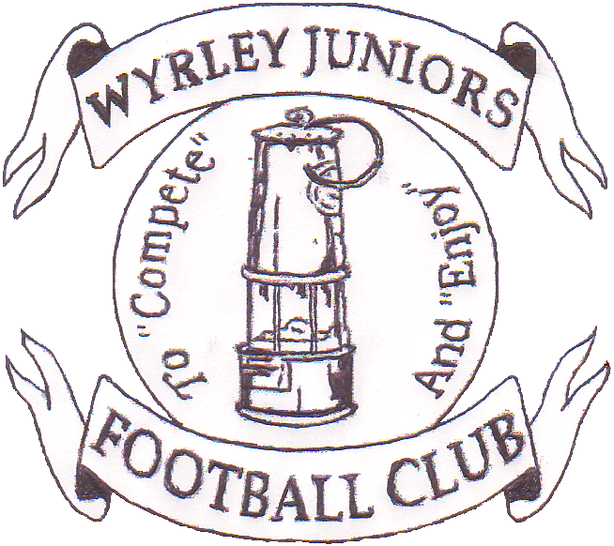

WYRLEY 7s

2016
At
Wyrley Juniors FC
Long Lane, Essington. WS6 6AT
Staffordshire Community club of the year
2004, 2006, 2009, 2011,2013 & 2015
West Midlands Region Community Club of the year 2006 & 2011
National Community Club of the year 2011
The Queens Award for Voluntary Service 2013
Sport across Staffordshire and Stoke Community Club of the Year 2015
You are invited to apply for entry into the 19th Wyrley Sevens.

Age Groups:
Saturday 11th June – Boys 6s 5v5, 8s 7v7 and 10s 9v9
Sunday 12t^{h} June – Boys 7s 5v5, 9s 7v7 and 10s 9v9
6s, 7s, 8s and 9s WILL HAVE 2 X LEAGUES OF 6 TEAMS
10s WILL HAVE 1 LEAGUE OF 6 TEAMS ON EACH DAY
Entry Fee:
£30 per team, payable upon application.
Teams will be accepted into the tournament in the order application forms are received, although the organising committee reserve the right to refuse entry.
Tournament places are limited due to new venue, apply early to avoid disappointment. Places are not confirmed until payment has been received.
PLEASE SPECIFY ON THE APPLICATION FORM FOR UNDER 10S ONLY IF YOU WOULD LIKE TO PLAY ON SATURDAY OR SUNDAY. THIS WILL BE ALLOCATED ON A FIRST COME FIRST SERVED BASIS.

Facilities:
Qualified First Aiders, Wyrley Juniors Club House with licensed bar. Hot and Cold drinks and food available. Football clothing Stall, Photographer, ice cream man.
Entry to site: £2 per Adult.
A strict one way system will be adopted, a drop off area will be provided on site, Marshalls will be directing traffic.
Car Parking is limited so car sharing where at all possible would be much appreciated.
No parking will be allowed in Long Lane due to this being a residential area.

To: Kate Foreman, 6 Shanklin Close, Walsall, WS6 6LZ
email:kateforeman@sky.com Telephone:07715282559
Name:........................................................ Email .........................................................................
Address....................................................................................................................................................................................................................................................................................................
Telephone.........................................................................................................................................
Club Name.................................................................
FA Affiliation no.............................................
Please find enclosed a cheque for £...............payable to Wyrley Juniors FC to cover entry into the following age groups
Saturday 11th June: Under 6s..................... Under 8s…………………………
Under 10s………………………
Sunday 12th June: Under 7s………………………… Under 9s……………………….
Under 10s…………………………
Team Colours..............................................
Affiliated League……………………………………………….

