**TAKING FOOTBALL TO AFRICA AND BEYOND CHARITABLE APPEAL**

**KENYA DELIVERY VISIT – 26 DEC 14 – 4 JAN 15**

The Taking Football to Africa and Beyond Charitable Appeal has been running since 2006 with its base at RAF Shawbury in Shropshire. It is organised by Wing Commander Neil Hope MBE and is linked to the RAF, RAF Shawbury and RAF Football Association (Neil is SO1 Danger Area Airspace Manager for the RAF through the Air Traffic Management HQ based at RAF Shawbury but working for Air Command). The Appeal is designed to deliver Aid through the global appeal of football. Kits are regularly donated through clubs from the national team, down through the leagues to grassroots teams, in addition to many personal donations from members of the public.

The Appeal, which has delivered over 102000 items of football kit (including over 34500 football shirts), sports equipment and school clothing and equipment to 48 countries worldwide since its inception, regularly completes delivery trips to Kenya, in East Africa, as the country where the appeal has its best links and delivery routes. Over the years over 30 different people, from members of the Armed Forces through to members of the Football Association as well as civilians, have travelled to Kenya with Neil to make kit deliveries in some of the poorest areas of the country.

On Boxing Day 2014, Neil and his wife Helen and daughter Charlotte travelled to Nairobi, accompanied by Flight Lieutenant Tony Kinchley (Tony is an Instructor on the Central Air Traffic Control School at RAF Shawbury) and his girlfriend, Nicola Keddie, to make deliveries during a holiday. Tony has assisted with the Appeal since its beginning and was making his 4th trip to Kenya. This was to be Neil’s 10th trip. Whilst holidaying the group decided to also make deliveries of kit donated by a multitude of clubs.

The first deliveries were completed at Gilgil. Gilgil is a small town around 2 hours north of Nairobi. It is a very poor town with many street children. Mary Coulson runs a re-start centre in the town for these children. For many years the centre was in an old building to the south of the town but Mary has worked tirelessly over the years to gain the funds to build a new centre and in December 2014 the children moved to the new centre to the east of the town. The new centre is a fantastic improvement and is purpose built in all areas. The 107 children are taught and live at the centre as well as being clothed and fed. <http://www.restartafrica.org/about-us/projects/restart-centre/>

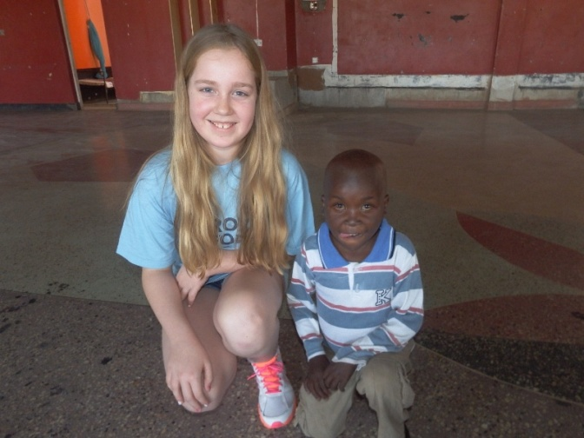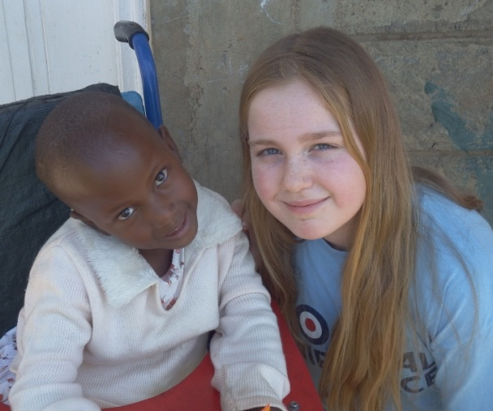

*Charlotte Hope at the Loving Hands Centre in Gilgil Charlotte with Gill Baraka at the Saidia Children’s Home in Gilgil*

Whilst in Gilgil the team visited and made deliveries at 2 more charities. The 2 are linked through the work of Jane Kinruthia. Jane was one of the founding members of the Saidia Children’s Home. The home is currently home to 56 children, most of whom were abandoned at birth or in infancy and many who were physically and sexually abused as babies or toddlers. The team were shown around the centre by Michelle Leroux, one of its Directors. Michelle holidayed in Kenya from Canada many years ago and fell in love with Kenya, Gilgil and the fantastic work completed at the centre. One little girl at the centre has become very close to the Hope family. Neil (and Tony) first met Gill Baraka when she was only a few months old. Gill was abandoned at birth as she was born with Spina Bifida. She was taken in by Saidia and is now a happy smiling 4 year old, approaching school age. Charlotte met Gill in October 2013 on a family visit and fell for her lovely smile. The main reason for this family holiday was down to Charlotte wanting to go and see Gill. Whilst wheelchair bound she is a fabulous young lady. <http://www.saidia-gilgil.org.uk/Saidia.shtml>

Jane Kinruthia has now moved from Saida and has set up a new Rescue Centre in the middle of Gilgil. The Loving Hands Centre is based in an old Disco on the first floor of an old building. It has 15 children, who Jane has rescued from the streets. All 15 children are HIV+ and some are quite ill. Jane provides a home, food and health care for the children. The children are happy and play and learn just like other children of their age although their life expectancy is obviously not great.

Whilst in Gilgil the team made time to visit and pay respects at the Gilgil War Cemetery. The cemetery is run by the Commonwealth War Graves commission and is a beautiful oasis in the town. It houses 225 graves with one from the First World War and all the others from either the Second World War or the Mau Mau Uprising in the late 1950’s and early 1960’s. It is intended to include the cemetery in the June 2015 schedule as well as the cemetery in Nairobi as part of the Military Development for those Forces members of the trip. <http://www.cwgc.org/find-a-cemetery/cemetery/12209/GILGIL%20WAR%20CEMETERY>

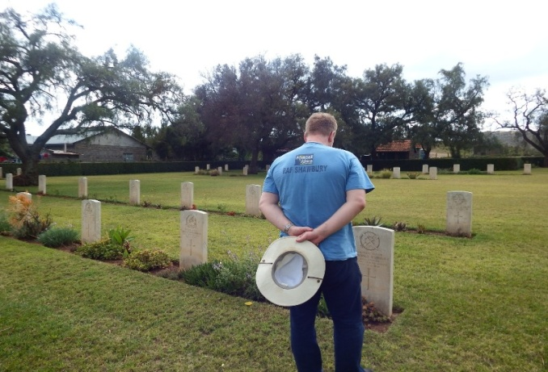

*Neil Hope at Gilgil War Cemetery*

The next delivery was a new one for the Charity and meant a first visit to the beautiful area near Thika, an hour north of Nairobi. The Kandara Children’s home is in the small village of Muranga and was suggested as a possible target for a delivery by the Appeal friend Kirsty McLullich, who works for Vision Africa in Nairobi. The home has 77 children ranging from babies to age 13. The children are eventually rehomed through fostering, or adopted or go back to their original families, if it is safe to do so. It provides full care and housing for the children but they school locally, where possible. <http://www.vision-africa.org/what_we_do/childrens_homes/kandara_childrens_home.php>

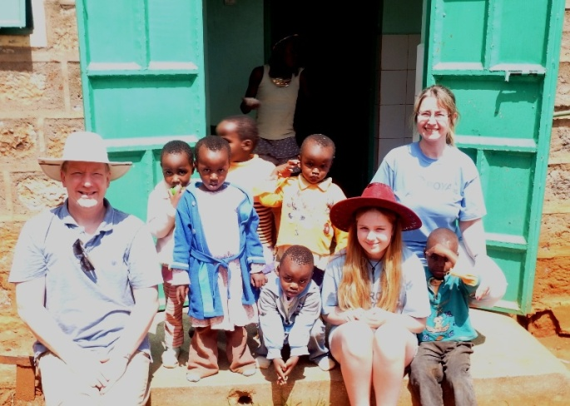

*Neil, Helen and Charlotte Hope at Kandara Children’s Home*

Back in Nairobi the team revisited old friends in Mountain View and Kibagare. In Mountain View a delivery was made to the Hope House Orphanage. The Orphanage has around 10 babies and a dozen toddlers, all of whom were either abandoned at birth or abused and taken from their parents. The children remain at Hope House until they can be fostered or adopted either in Kenya or overseas. <http://www.hopehousebabieshome.co.uk/>

Kibagare is a slum area of shacks which house over 20000 people in the north of Nairobi on the Naivasha road. In Kibagare the team visited the inspirational Sister Leah at the Good News Centre. The centre started as a small corrugated shack building and has progressed to be a fairly large school teaching 650 children on a daily basis. In addition to the children, aged from 4 to 18, they also provide a feeding programme for children from the slum area each Saturday during which they feed 1700 children. Sr Leah and the other Sisters are inspirational women who are teachers, business women and carers all rolled into one. Sr Leah showed us around the school and explained how it works before taking us for a walk into the slum area. This walk included visits to a few of the shacks. In one shack a family of 7 live in an area the size of a small bathroom in the UK. The heat in the shack was unbearable. Sr Leah will shortly retire by moving to another school of just 200 children as she feels the Good News Centre is too stressful as she is now 70 years old. She is an inspiration to all. <http://kibagaregoodnewscentre1.org/>

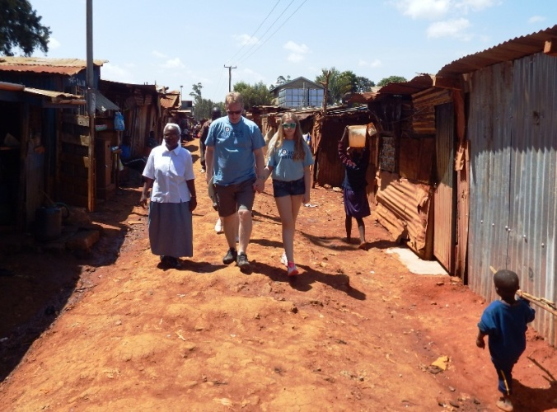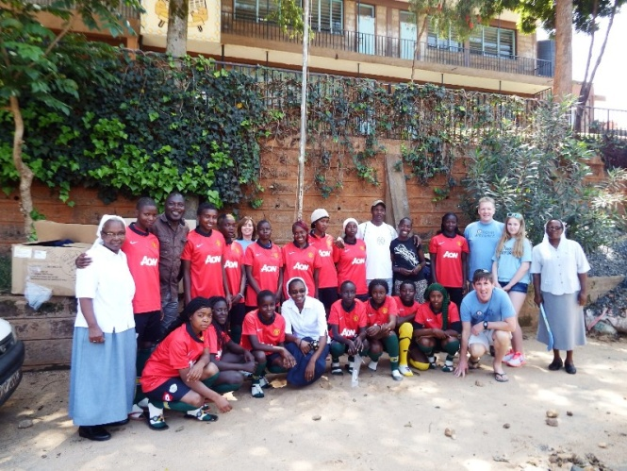

*Neil and Charlotte Hope with Sr Leah in Kibagare Slum With Sr Leah and Sr Emma and Kibagare Ladies FC*

Also in Kibagare the team met with Pastor Amos Okolo and visited the work in progress of his new school. He cares for 50 children in a shack building but is currently building a new school building. The school educates children aged between 3 and 9. His new building will have a room for children below this age as they are often left alone at home whilst their parents try to make a living.

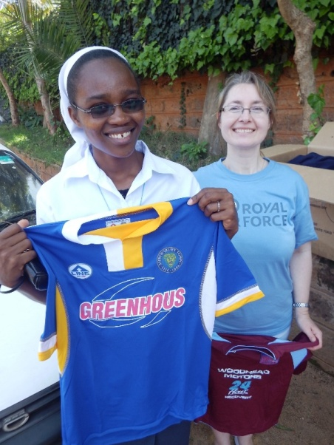

*Helen Hope and Sr Anne at KGNC*

The first deliveries of 2015 took place in Mathare and Kibera slums. Mathare is a large area near the centre of Nairobi which is a mix of large concrete buildings in terrible condition and also some large shack areas. In Mathare the team visited the small Stella Maris School. The school contains 10 very small classrooms and provides education for an incredible 296 children ranging from 3 to 17 years. The nursery class is small yet has 63 children! The school has an amazing staff who are totally committed to teaching their children. One of the teachers explained that they had qualified as teachers and wanted to give back to the area they grew up in. They receive a monthly wage equivalent to £28!

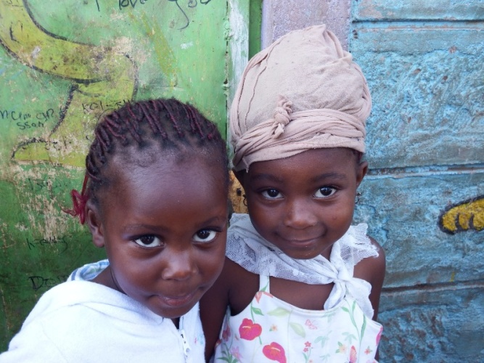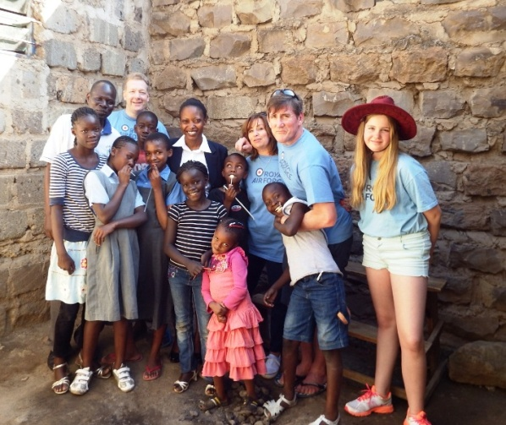

*Girls at Stella Maris School in Mathare Slum Stella Maris School in Mathare Slum*

Kibera is very well known across the world. It is one of Africa’s largest slum areas housing around 1 million people in area of around 3 square kilometres with little running water or electricity and no sewerage system. The sights and smells of Kibera cannot accurately be explained. It is an incredible area, and certainly not in a good way. In Kibera the team visited the SlumSoka organisation, who provide an outlet for children and young adults through football. The team were met by Godfrey and Calvin who took them on amazing journey through the alleyways to a small football pitch towards the north western edge of the slum. At SlumSoka the team also made deliveries to 3 other schools and teams that have become friends in this incredible area. Oloo School is a small school housing around 250 children which was set up and run by Judith Oloo. Mpira Mtaani is a youth organisation run by Vincent Kekode which teaches children and young adults through football linking to education and health care. Vincent also looks after the small Rotary School which provides education for youngsters from 3 to 9 years old. Finally the team met again with John Oyoo, the Chairman and organiser of the Kibera Celtic football team. Kibera Celtic started as an outlet for youngsters through football and now has many teams including a first team which has progressed to the second tier of Kenyan football. <http://www.kibraleague.org/about/>

<http://kiberampiramtaani.org/> <http://www.olooschool.co.uk/about-kibera/>

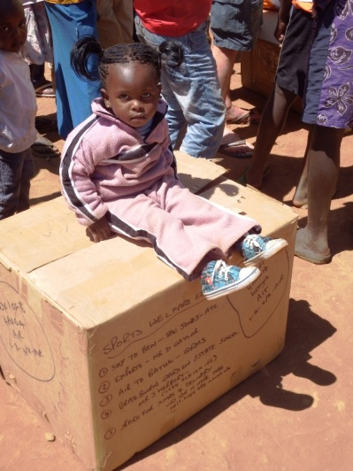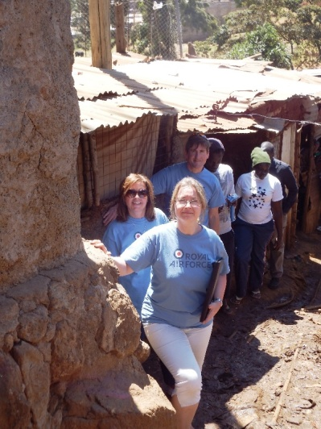

*Kibera Slum*

In addition to the deliveries made in person the team left kit for Chelate Primary School in Runda in Nairobi, as well as a youth team linked to Braeburn Garden Estate School (where all the kit is stored by its Executive Headmaster, John Herbert, who is from Shrewsbury and whose parents still live in Shrewsbury) and also for the staff and workers at the incredible Alive and Kicking Factory. Finally a bag of kit was left with Pam Galley for distribution through the East African Women’s League.

Yet again this was a fantastic visit during which we met and visited many inspirational people who take time to care and help others. It is always an incredible place to visit and leaves the team in awe of some fabulous people whilst remembering some fabulous children who never fail to smile. The trips always provide for an emotional roller coaster ride which will never be forgotten. For Service personnel there can be few better self-improvement or force development opportunities than these visits. Trips are fully self-financed and the next visit leaves the UK on 31st May 2015. Places are still available.

Many thanks to all the people that make the Appeal possible especially R&D at RAF Shawbury, ATC at RAF Brize Norton and the troops at BATUK in Kenya along with the people at Braeburn Garden Estate School in Nairobi.

Thanks also to the long list of clubs and organisations who donated the items distributed on this visit: Antalis, Tim Oakes, QPR, Nova International, Leicester City, Ann Lewis, Charlotte Hope, Millmoor Juniors, Woden Primary School, Wryley Juniors, Manchester United Foundation, Weston Juniors, Energize Shropshire, Dave Hale, The FA/England, Nike, Childs Ercall Church Group, Wolverhampton Wanderers, Shifnal Harriers, Dronfield Town, Broseley Sports, Shrewsbury Town, Dinnington Town, Middlewood Rovers, Sheffield & Hallamshire CFA, Warndon Village JFC and Mrs Archer.

For further details or to donate please contact Wg Cdr Neil Hope MBE on 01939 250351 Ext 7101 or 07903135508 or [neil.hope684@mod.uk](mailto:neil.hope684@mod.uk) or through the RAFFA at <http://www.royalairforcefa.com/>

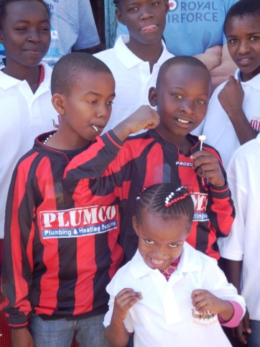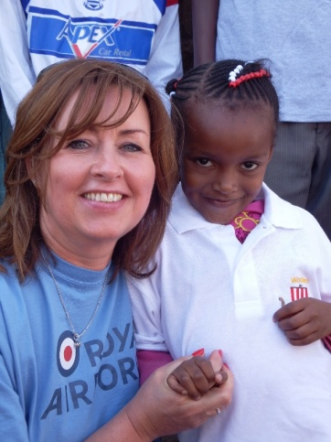

*Stella Maris School in Mathare Slum Nicola Keddie at Stella Maris*

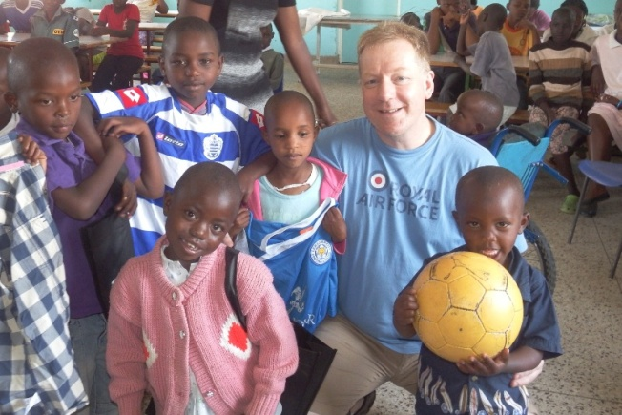

*Neil Hope at Saidia Children’s Home*