Wyrley 7s
2013
8th & 9th June 2013
At
Great Wyrley Performing Arts High School, Hall Lane, Great Wyrley, Staffordshire. WS6 6LQ

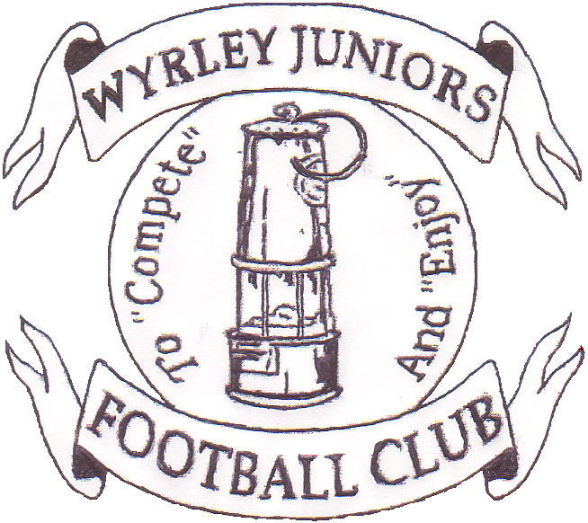

STAFFORDSHIRE COMMUNITY CLUB
OF THE YEAR
2004, 2006, 2009 & 2011
WEST MIDLANDS REGION
COMMUNITY CLUB OF THE YEAR
2006 & 2011
NATIONAL COMMUNITY CLUB OF THE YEAR 2011

Name Of league Team/s Play In……………………………
Team Colours……………………..
Any Queries?.....................................................
Name Of league Team/s Play In……………………………
Team Colours……………………..
Any Queries?.....................................................

To: Mrs C. Ponder, 70 Chetwynd Park, Rawnsley, Cannock, Staffordshire. WS12 0NZ Tel. 07917191263
You are invited to apply for entry into the sixteenth Wyrley Sevens. The
Tournament is recognised as one of the best organised and largest in the UK.

Name:…………………….
Address: ………………………………………………………………………………………………………………………………………………….
Tel: Home:
……………………....................
Mobile: ……………………….

…………………………..
Name Of league Team/s Play In……………………………
Team Colours……………………..
Any Queries?.....................................................
Name Of league Team/s Play In……………………………
Team Colours……………………..
Any Queries?.....................................................

Saturday 8th June – Boys - 7s, 9s, 11s, 13s, 15s. Girls – 12s, 16s
Sunday 9th June – Boys - 6s, 8s, 10s, 12s, 14s, Girls - 10s, 15s

Club Name: …………...……………………FA Affiliation No............……..
Email: …………………………
A fee of £25 per team is payable.

Please find enclosed a cheque for £ payable to Wyrley Juniors FC to cover entry in the following age groups: -
Boys under 7’s to 12’s and girls under 10’s and 12’s will play seven-a-side.
Boys Under 6s and girls and boys under 13’s to 16’s will play 5-a-side.
Maximum squad sizes will be 12 for all teams

Saturday
8th June
No of Teams
Sunday No of teams
9^{h} June

Boys Under 7 ………….

Boys Under 9 .………...

Boys Under 11 …………

Boys Under 13 …………

Boys Under 15 ………….

Girls Under 12..................

Girls Under 16 …………

Boys Under 6 ………….

Boys Under 8 …………

Boys Under 10 …………

Boys Under 12 .. .……….

Boys Under 14 .. ……….

Girls Under 10 ...................

Girls Under 15 ….……...

Teams will be accepted to the tournament in the order application forms are received, although the organising committee reserves the right to refuse entry. Confirmation of acceptance to the tournament will be forwarded within 14 days of the tournament.

Paramedics, football clothing stall, photographer, hot and cold food and drinks, licensed bar at nearby Old Wyrley Hall; ample free car parking space. PLEASE NOTE: Due to health and safety reasons no dogs or barbeques are allowed on site.

This will be gained by purchase of a £2 programme for all adults.

Name Of league Team(s) Play in…………………………………….

Team Colours……………………..

Queries and return of application to:
Mrs Candy Ponder, 70 Chetwynd Park, Rawnsley, Cannock, Staffordshire. WS12 0NZ Telephone: 07917191263 (after 6.00p.m. on
Weekdays)

Age Groups
Entry Fee
Teams And Squad Size
Entry
Facilities
You are invited to apply for entry into the ninth Wyrley Sevens. The tournament is recognised as one of the best organised and largest in the UK.
Saturday 13th May– Boys Under– 7’s, 8’s, 9’s, 11’s, 12’s, 13’s and 15’s.
Sunday 14th May– Boys Under— 8’s, 9’s, 10’s, 11’s, 12’s, 14’s and 16’s.
Saturday 20th May– Girls Under– 10’s, 11’s, 12’s, 13’s, 14’s, 15’s and open age.
A fee of £20 per team is payable.
Boys under 7’s to 12’s and girls under 10’s to 14’s will play seven-a-side.
Boys under 13’s to 16’s and girls under 14’s to open age will play 5-a-side.
Maximum squad sizes will be 10 for all teams.

Teams will be accepted to the tournament in the order application forms are received, although the organising committee reserves the right to refuse entry. There will be a maximum of 12 teams per age-group per day.
Confirmation of acceptance to the tournament will be forwarded within 10 days of the tournament.

